

Bachelor of Computer Applications
Semester – V
Deep Learning
Project No.: 3
Title: Comparison of Deep Learning Architectures

Submitted By:
Name: Anuska Ghosh
Reg. No.: 2411021240012
Date: 31/08/26

Submitted To:
Faculty Name: Ms. Nagasri P

Department of Computer Application
Alliance University
Chandapura - Anekal Main Road, Anekal
Bengaluru – 562106

Introduction
Deep Learning has multiple types of neural network architectures, and each one is built differently because each one solves a different kind of problem.
In this project, we will study three major architectures:
- Feedforward Neural Networks (FNN)
- Convolutional Neural Networks (CNN)
- Recurrent Neural Networks (RNN)
We will look at how each one is structured, what kind of data it works best with, and where it is actually used in the real world.

Task 1: Basic Architecture of Each Network
1.1 Feedforward Neural Network (FNN)
A Feedforward Neural Network is the simplest and most basic type of neural network. Data moves in only one direction, forward, from the input layer, through the hidden layers, and finally to the output layer. There are no loops, no going back.
Each neuron in one layer is connected to every neuron in the next layer. The basic calculation happening inside each neuron is:
z = w₁x₁ + w₂x₂ + ... + wₙxₙ + b
Then this value z is passed through an activation function (like ReLU or Sigmoid) to get the final neuron output.
Simple Architecture Diagram:
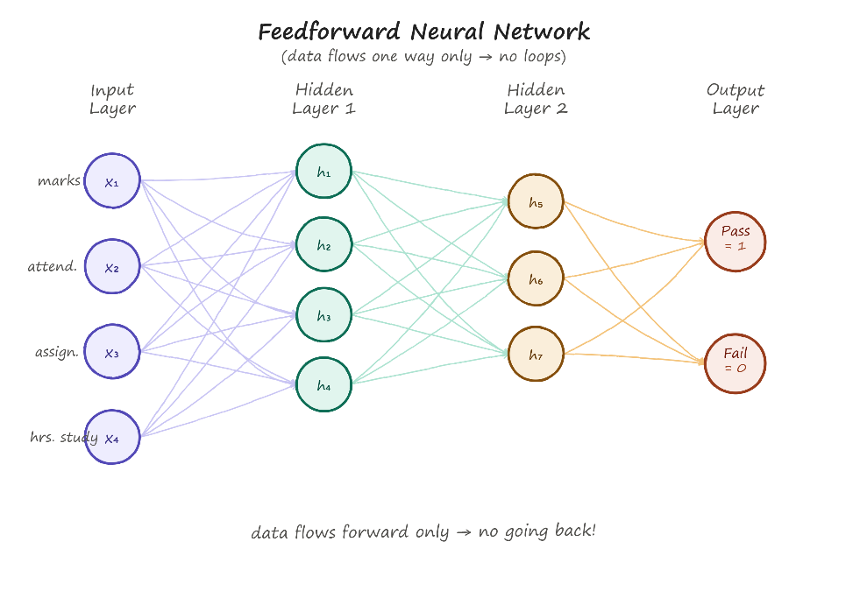

Working of FNN:
- Input values are fed into the input layer
- Each input is multiplied by its weight
- Bias is added to the weighted sum
- Activation function is applied
- Result passes to the next layer
- Final layer gives the prediction
- Loss is calculated (how wrong was the prediction?)
- Backpropagation updates the weights so next time it's better

1.2 Convolutional Neural Network (CNN)
CNN is specially designed for image and visual data. A normal FNN would struggle with images because an image has thousands or millions of pixels, and treating each pixel as a separate input becomes computationally impractical. CNN solves this by using filters/kernels that scan across the image and detect features like edges, shapes, textures, and eventually full objects.
Main Components of CNN:
- Convolution Layer
Definition: The convolution layer applies filters or kernels to the input image to detect important features. A filter moves across the image and performs mathematical operations to produce a feature map.
Example: A filter may detect:
● Vertical edges
● Horizontal edges
● Corners
● Textures
Different filters learn different features.
- Kernel / Filter
Definition: A kernel is a small matrix of numbers that moves across the input image to detect specific features.
Example of a simple 3 × 3 filter:
1 0 -1
1 0 -1
1 0 -1
This type of filter can help detect vertical edges.
- Feature Map
Definition: A feature map is the output produced after applying a convolution filter to an input image. It shows where a particular feature has been detected.
Example: If a filter detects vertical edges, the resulting feature map contains high values in areas where vertical edges are present.

- Pooling Layer
Definition: Pooling reduces the spatial size of feature maps while retaining important information.
Common types: ● Max Pooling ● Average Pooling
Max Pooling
Definition: Max pooling selects the largest value from a small region.
Example:
2 5
3 1
Max pooling gives: 5
Max pooling helps reduce computation and retains strong features.

- Fully Connected Layer
Definition: A fully connected layer connects the learned features to the final output classes.
Example: After CNN layers detect features such as – Eyes, Nose, Ears, Fur
The fully connected layer uses these features to predict: Cat = 95% Dog = 5%

Simple Architecture Diagram:
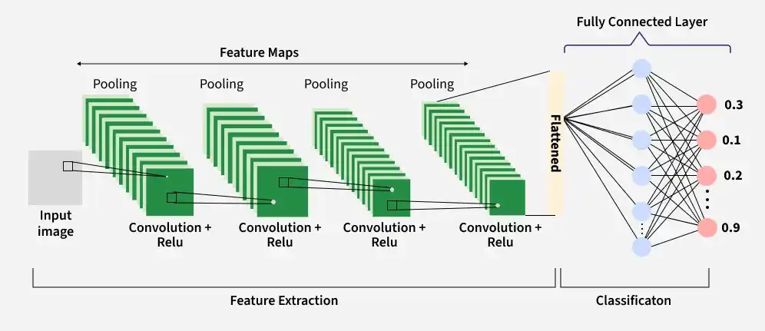

1.3 Recurrent Neural Network (RNN)
RNN is designed for sequential data, data where the order matters. In a sentence, the meaning of a word depends on the words that came before it. In a time series, today's value depends on yesterday's values. FNN and CNN cannot handle this because they don't have any memory of previous inputs.
RNN solves this by maintaining a hidden state, a kind of memory that carries information from one step to the next.
The equation for the hidden state is:
hₜ = f(Wₓxₜ + Wₕhₜ₋₁ + b)
Where hₜ₋₁ is the hidden state from the previous step and xₜ is the current input.
Simple Architecture Diagram:
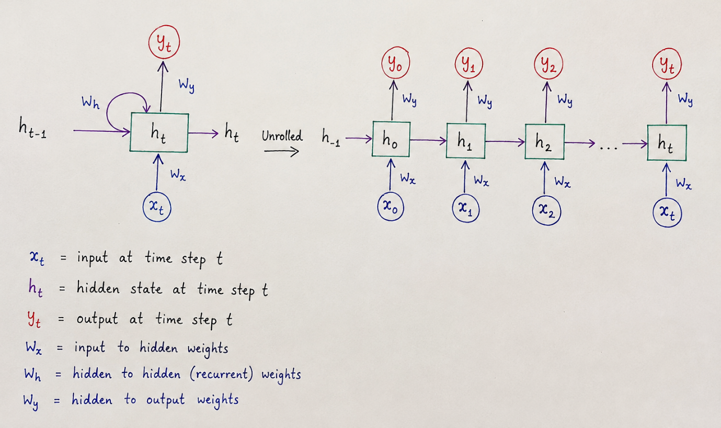
Variants of RNN:
LSTM | - Has 3 gates (Forget, Input, Output), better long-term memory
GRU | - Has 2 gates (Update, Reset), simpler than LSTM, trains faster

Task 2: Applications for each Architecture
2.1 Applications of Feedforward Neural Networks
FNNs work best when the input data is structured/tabular, meaning data that fits neatly into rows and columns (like a spreadsheet). There is no spatial relationship between features and no sequence to maintain.
Applications:
- Student Performance Prediction - Inputs: attendance, marks, assignment scores → Output: Pass/Fail
- House Price Prediction - Inputs: area, location, bedrooms → Output: Estimated price
- Credit Risk Prediction - Inputs: income, loan history, age → Output: Low/High risk
- Medical Diagnosis (structured data) – Inputs: age, blood pressure, test results → Output: Disease/No disease
- Fraud Detection (basic) - Inputs: transaction amount, location, time → Output: Fraud/Not fraud
Real-world Example: A bank in India can use FNN to predict whether a home loan applicant is likely to default, based on their salary, credit score, and existing loans.

2.2 Applications of Convolutional Neural Networks
CNNs work best when the input data has spatial structure, meaning data where nearby values are related to each other, like pixels in an image or values on a grid.
Applications:
- Face Recognition – Used in phones, Aadhaar systems, office attendance systems
- Medical Image Analysis – Detecting tumors in X-rays, MRIs, CT scans
- Object Detection – Identifying cars, pedestrians, traffic signs in real time
- Autonomous Vehicles – Self-driving car cameras use CNN to understand the road
- Handwritten Digit Recognition – Reading handwritten pin codes on envelopes
- Crop Disease Detection – A farmer's app that identifies diseased leaves from photos
- Facial Expression Recognition - Detecting emotions in a face
Real-world Example: Some Indian agricultural startups use CNN-based mobile apps where a farmer clicks a photo of a crop leaf, and the model tells them if the crop is infected and what disease it might be.

2.3 Applications of Recurrent Neural Networks
RNNs (and their improved forms LSTM/GRU) work best when the input data is sequential, meaning the order of inputs matters and context from previous steps is needed.
Applications:
- Sentiment Analysis – Reading a movie review and predicting if it's positive or negative
- Language Translation – Translating "Mujhe bhook lagi hai" "I am hungry"
- Speech Recognition – Converting spoken words into text (like Siri, Google Assistant)
- Next Word Prediction – Predicting the next word while typing (keyboard autocomplete)
- Stock Price Prediction – Using past stock values to predict tomorrow's price
- Weather Forecasting – Using past temperature/humidity data to forecast future weather
- Music Generation - Generating next notes based on previous musical sequence
Real-world Example: When we type on our Android or iPhone keyboard in Hindi or English, the autocomplete/autocorrect system uses RNN-based models to predict what word we are likely to type next.

Task 3: Comparison of Architectures
Feature | FNN | CNN | RNN
Full Name | Feedforward Neural Network | Convolutional Neural Network | Recurrent Neural Network
Structure | Input layer Hidden layer Output layer | Input Convolutional layer Pooling Fully Connected layer Output | Input RNN cell (with hidden state loop) Output
Input Data Type | Structured/tabular data (rows and columns) | Images, grids, spatial data | Sequential data (text, speech, time-series)
Data Flow | One direction only - no loops, no memory | One direction only - filter slides across input | Forward + loops back - hidden state carries memory
Feature Extraction | Manual or simple learned features | Automatic. Learns edges, shapes, objects layer by layer | Automatic. Learns context from previous steps in sequence
Memory of Past Input | No | No | Yes, hidden state remembers previous inputs
Order of Input Matters | No | No | Yes, sequence order is important
Applications | Student result prediction, house price prediction, credit risk | Face recognition, object detection, medical image analysis | Sentiment analysis, language translation, speech recognition
Example | Predict Pass/Fail from marks and attendance | Classify image as Cat or Dog | Predict next word in a sentence

Conclusion
All three architectures, FNN, CNN, and RNN, are important parts of Deep Learning. None of them is universally "the best." Each is designed for a specific kind of problem:
- FNN is the foundation - simple, fast, and works well for structured data where there is no spatial relationship or sequence dependency.
- CNN is built for visual understanding - it automatically learns spatial features from images, going from simple edges to complex objects layer by layer.
- RNN is built for understanding context over time - it remembers what it saw before, making it suitable for language, speech, and any data where sequence matters.
A real-world Deep Learning engineer does not pick an architecture randomly. They look at the type of input data, the nature of the problem, and the available computational resources, and then choose the architecture (or a combination of architectures) that fits best.

